Create a Standalone Table in CLM Document Generation

*Created by Lauren Wong (DocuSign)*

# Summary

This guide shows you how to create editable tables in a document generation form for DocuSign CLM, without Salesforce data.

# Prerequisites and limitations

## Prerequisites

Enable Advanced Mode in Doc Launcher Forms

* Verify if Enabled:
  + Open up any Doc Gen From. You should see the “Edit as JSON” text on the left side, below Advanced Settings.

Request to Enable:

* + Please open a Support Case to request feature activation. Make sure to specify the DocuSign Account ID, if it is demo or production, & request activation of the “Enable Advanced Mode in Doc Launcher Forms.” The Support Engineer will likely request delegated access to be able to access the Account Settings.
  + Partners can open a support case through the DocuSign Partner Portal, or via the DocuSign Support Center using partner portal login credentials.

Note: For more information about considerations with “Edit as JSON”, see the *Edit As JSON* section in the *Additional Information* section of this guide.

# Architecture

The following diagram shows an architecture for a standalone table deployed in a DocuSign demo environment to show a payment schedule.

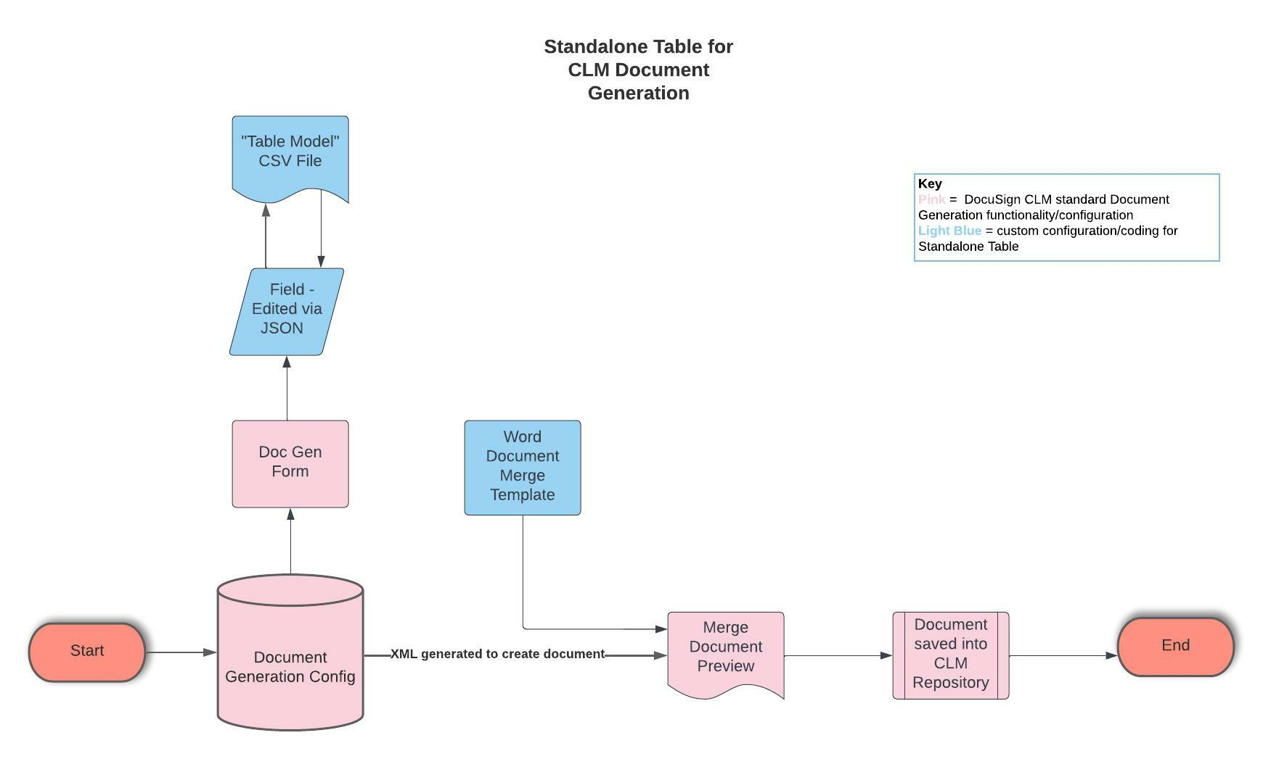

The diagram shows the following components:

1. The merge template document
2. JSON for the table field
   1. Version 1: just the table json (table field.json)
   2. Version 2: an example of conditionally showing the table based on the selection of another dropdown field "Payment_Terms"
3. CSV
   1. To designate how many rows the table will be and,
   2. To prefill values for demo purposes (you can also start with a blank table)

**Result**:

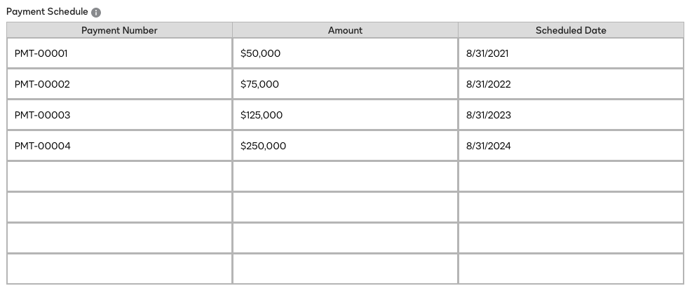

# Epics

1. **Define the Table**

| **Task** | **Description** | **Skills Required** |
| --- | --- | --- |
| Define Table in CSV File | In the CSV, the RowNumber column is simply used to add rows. This column is hidden in the Document Generation tool. The other 3 columns are shown to the user for them to complete the table data. In the attached example we are prefilling the first 4 rows so that data doesn't have to be typed in real time during a demo.  The table field can also pull from XML if you have data in that format. The ExtractionSourceId in the field JSON will need to be updated. | CLM Implementation Consultant / Business Analyst |

1. **Configure the Table in Doc Gen Form Builder**

| **Task** | **Description** | **Skills Required** |
| --- | --- | --- |
| Define Table in CSV File | In the CSV, the RowNumber column is simply used to add rows. This column is hidden in the Document Generation tool. The other 3 columns are shown to the user for them to complete the table data. In the attached example we are prefilling the first 4 rows so that data doesn't have to be typed in real time during a demo. | CLM Technical Consultant |

1. **Configure Merge Template**

| **Task** | **Description** | **Skills Required** |
| --- | --- | --- |
| Configure Merge Template | Set up DocuSign CLM Merge Template.  The template fields are exactly the same as any other table, except the [Amount != ''] is removing any table rows where the Amount is blank. This is because you have to set your standalone table to a default number of rows, and the user cannot dynamically add/remove the rows in the UI. | CLM Implementation Consultant |

# Related resources

* [Word Template Merge Tags](https://support.docusign.com/s/document-item?language=en_US&bundleId=uqj1643324072491&topicId=uno1576795541214.html&_LANG=enus) (DocuSign CLM Document Generation Guide)
* [CLM Environment Checklist](https://app.esign.docusign.com/e/er?utm_campaign=WW_MKTG_PART_PartnerProgramUpdateJuly2022_2022-07&utm_medium=email&utm_source=Eloqua&s=566810826&lid=29380&elqTrackId=473af1d78ace401dbb6a01be65ad22ca&elq=7496961e44854ba098a76718a07455eb&elqaid=56815&elqat=1) (Partner Portal)

# Additional information

## Sample Table for Merge Template

| **Amount** | **Month and Year of Payment** |
| --- | --- |
| <# <TableRow Select="//Payment_Schedule[Amount != '']" /> #><# <Content Select="./Amount" Optional="true"/> #> | <# <Content Select="./Scheduled_Date" Optional="true"/> #> |

## Edit as JSON

DISCLAIMER: Document generation fields configured using JSON are not supported by DocuSign Support.

## JSON Fields to Change

* "displayName": "Payment Schedule"
  + Table title
* "ExtractionSourceId": "CsvDocument"
  + Can also be XML
* *"possibleFields"*
  + List out your column headers
* "Items" array
  + Need one entry for each column.
  + "width" - affects the UI for how the columns look
    - **Default is "FullWidth" b/c it looks best with a few columns, no extra spaces**
    - You can also try "ExtraWide" or "Narrow" depending on how your table looks
    - Example below with ExtraWide instead of FullWidth (notice extra space)

* + "displayName" is the column header that appears on the form
  + " visible" – either true or false
    - In this example RowNumber is set to false since it is only being used to set how many rows are in the table and does not need to be visible by the user
  + "readonly" – either true or false
    - You likely want all of these to be true so the table can be filled in
  + " TargetIdentifier" – tag that will go in your template
  + "SourceIdentifier" – column header from CSV that maps to this table column
* "TargetIdentifier": "Payment_Schedule"
  + Tag for table row
  + <# <TableRow Select="//Payment_Schedule[Amount != '']" /> #>
* "SourceIdentifier": "AID,"
  + This is the document ID for the CSV file
  + **THIS IS IN TWO PLACES**
* "AccountId"
  + Update for your account, AID can be found in any CLM URL
* "helpText"
  + Sets the tool tip text

# Attachments

To access additional content that is associated with this document, unzip the following file: Standalone_Table.zip.